Team Members:

Rajath Kotgere Manjunath (rkm350)

Rajat Ravindrakumar Bapuri (rrb398)

Sushanth Shabnavees (ss12376)

Part 1

1. **Write the direct kinematic equations in minimum parametrization.**

Following diagram illustrates the axes according to the DH conventions and the table gives the DH parameters.

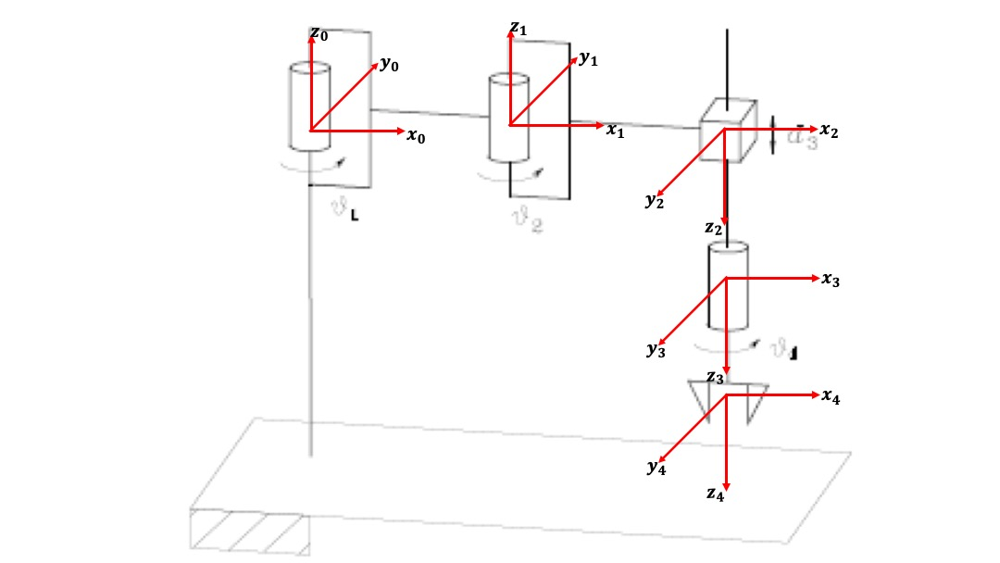

|  |  |  |  |  |
| --- | --- | --- | --- | --- |
| Link |  |  |  |  |
| Link 1 |  | 0 | 0 |  |
| Link 2 |  | 180° | 0 |  |
| Link 3 | 0 | 0 |  | 0 |
| Link 4 | 0 | 0 | 0 |  |

Direct kinematic equations are written as follows:

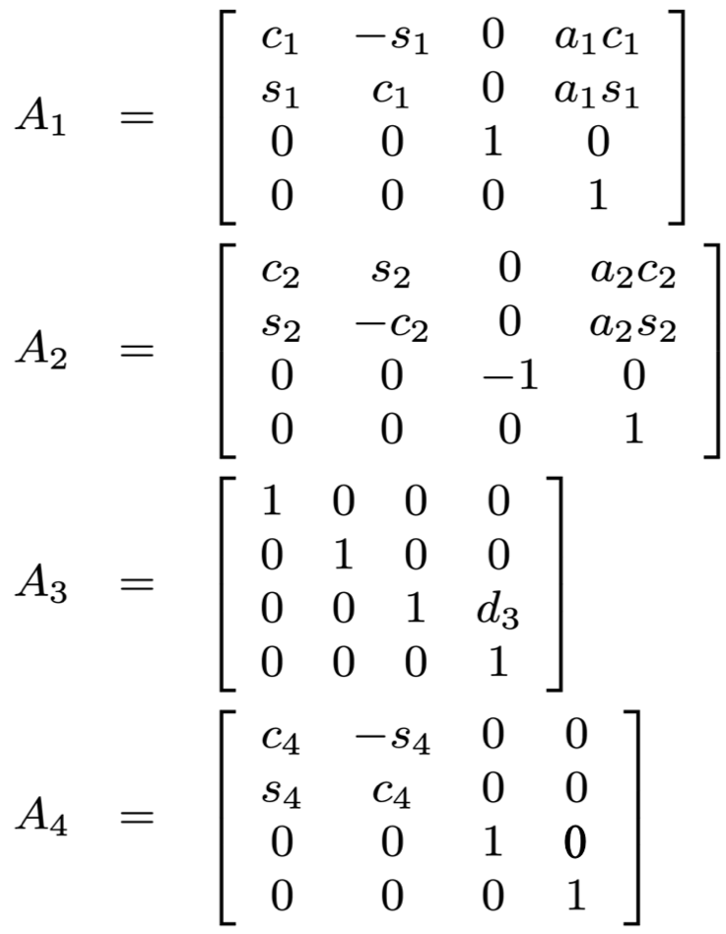

Final homogeneous equation is as follows:

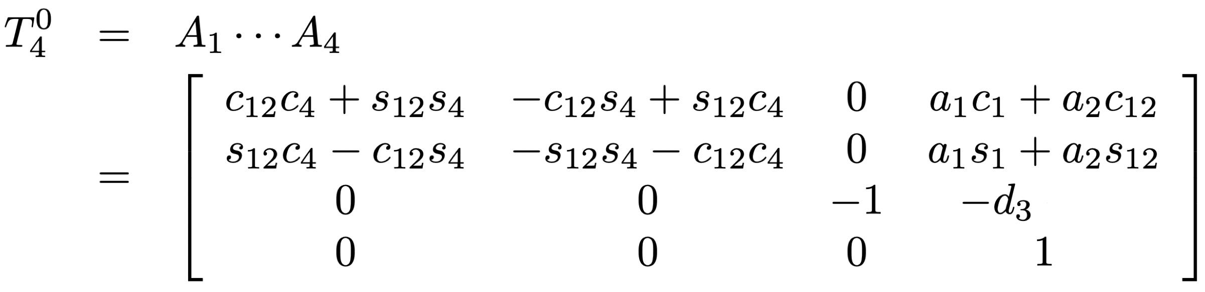

1. **Write the differential kinematic equations.**

Differential kinematic equations are as follows:

J =

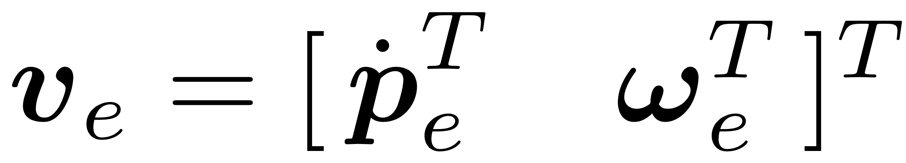

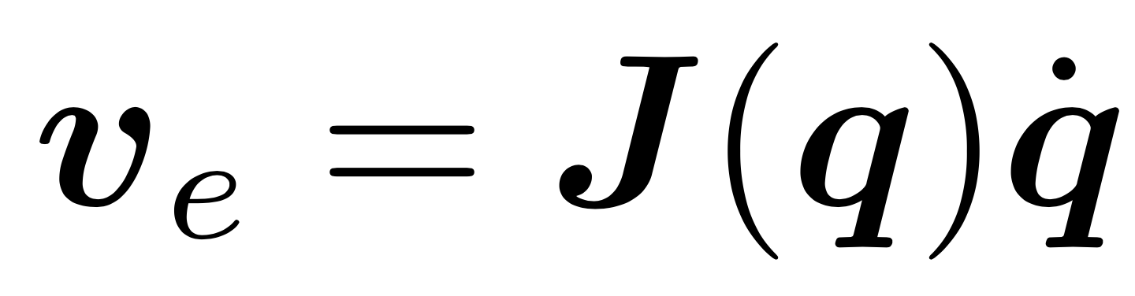

1. **Is the geometric Jacobian the same of the analytic one? Explain why.**

**The analytical jacobian and the geometric one is the same since the orientation part does not change and it is represented by a single angle.**

128

1. **Plot the the joint variables and the errors in the operational space.**

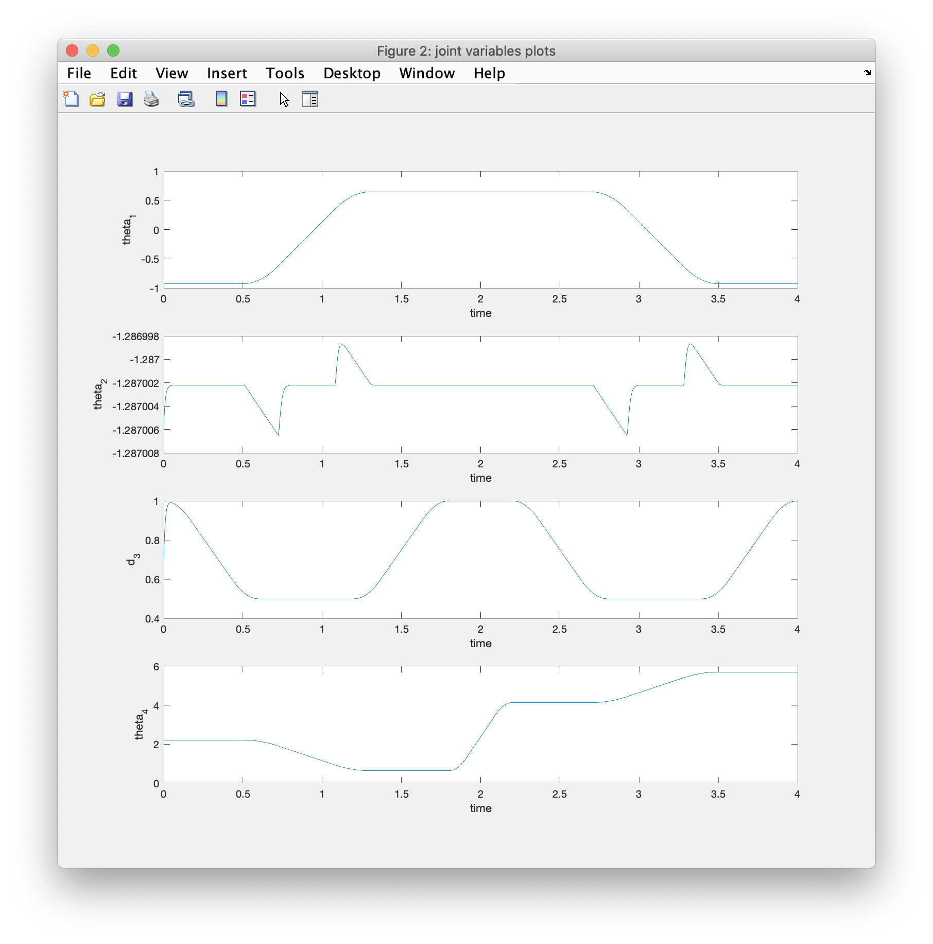

Joint Variables plot in the operational space:

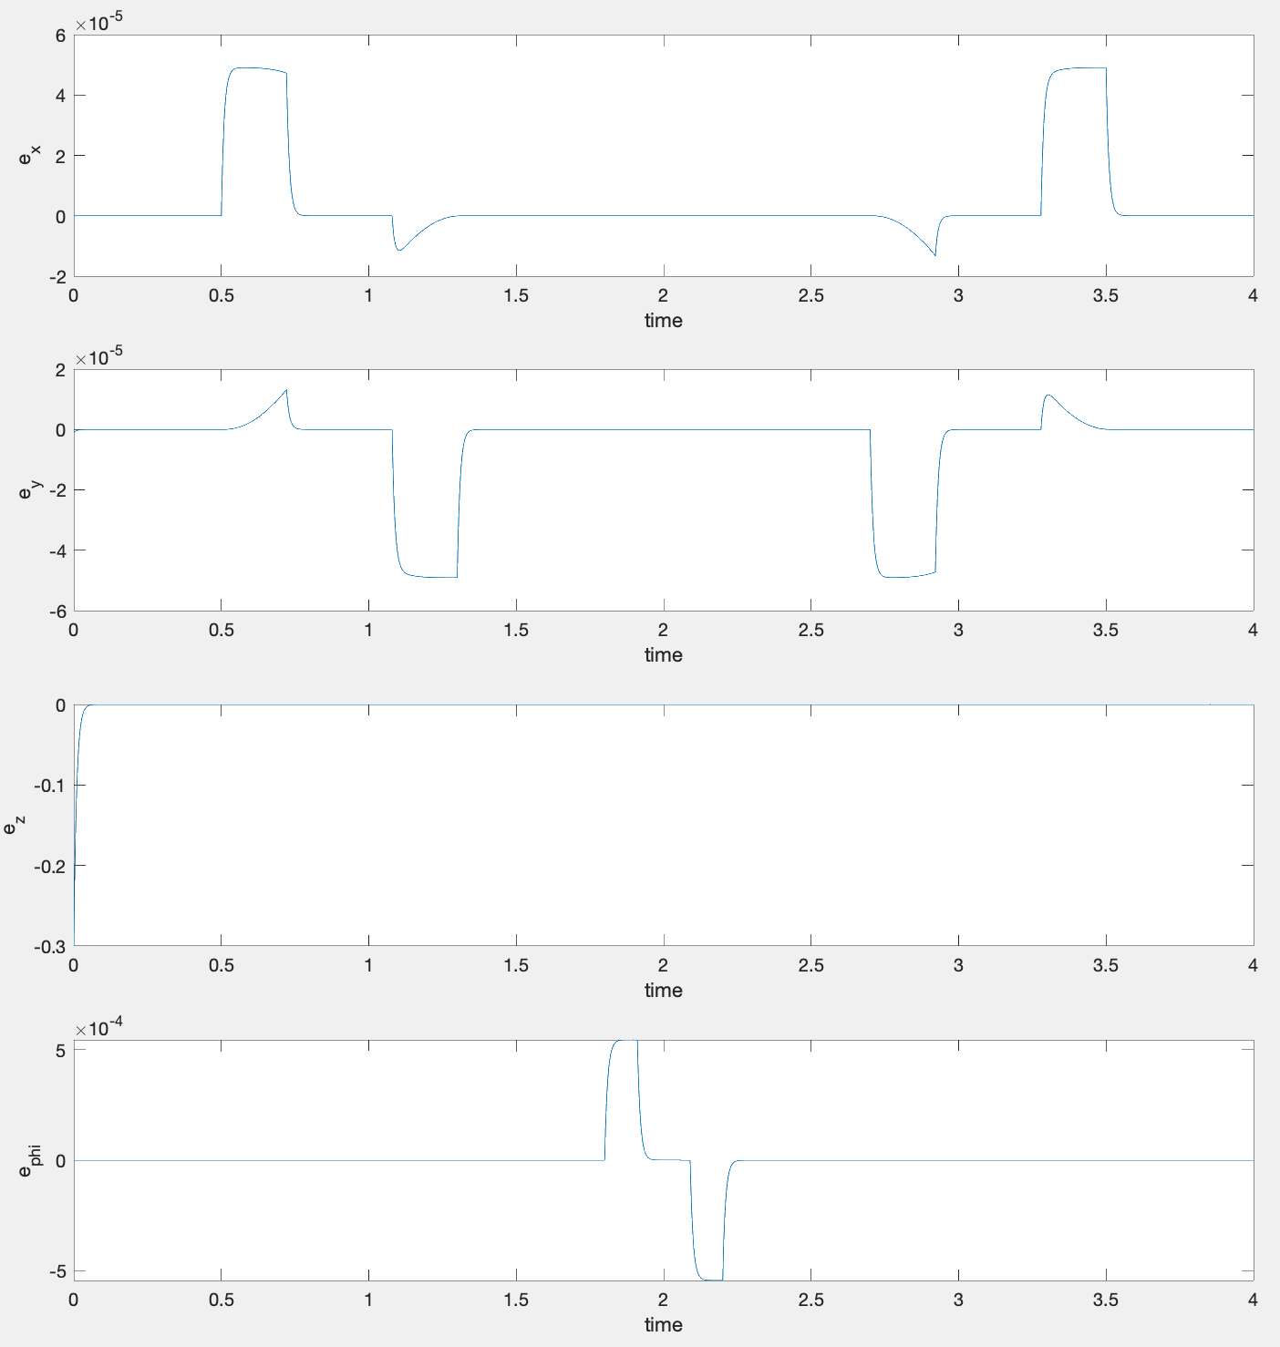

Error Variables plot in the operational space:

Part 2

**Relaxing the orientation component**

1. **Explain how you relaxed the phi and how you would write the jacobian pseudo-inverse**

To relax phi we removed the last row which i.e. phi from the Jacobian.

Jacobian Pseudo Inverse is written as:

1. **Write how you choose once relaxed z to obtain the maximum distance from the end joints**

Distance between centre of the sphere and the

1. **Plot the joint variables and errors in the operational space. Explain the how the constraints are satisfied relaxing that component**

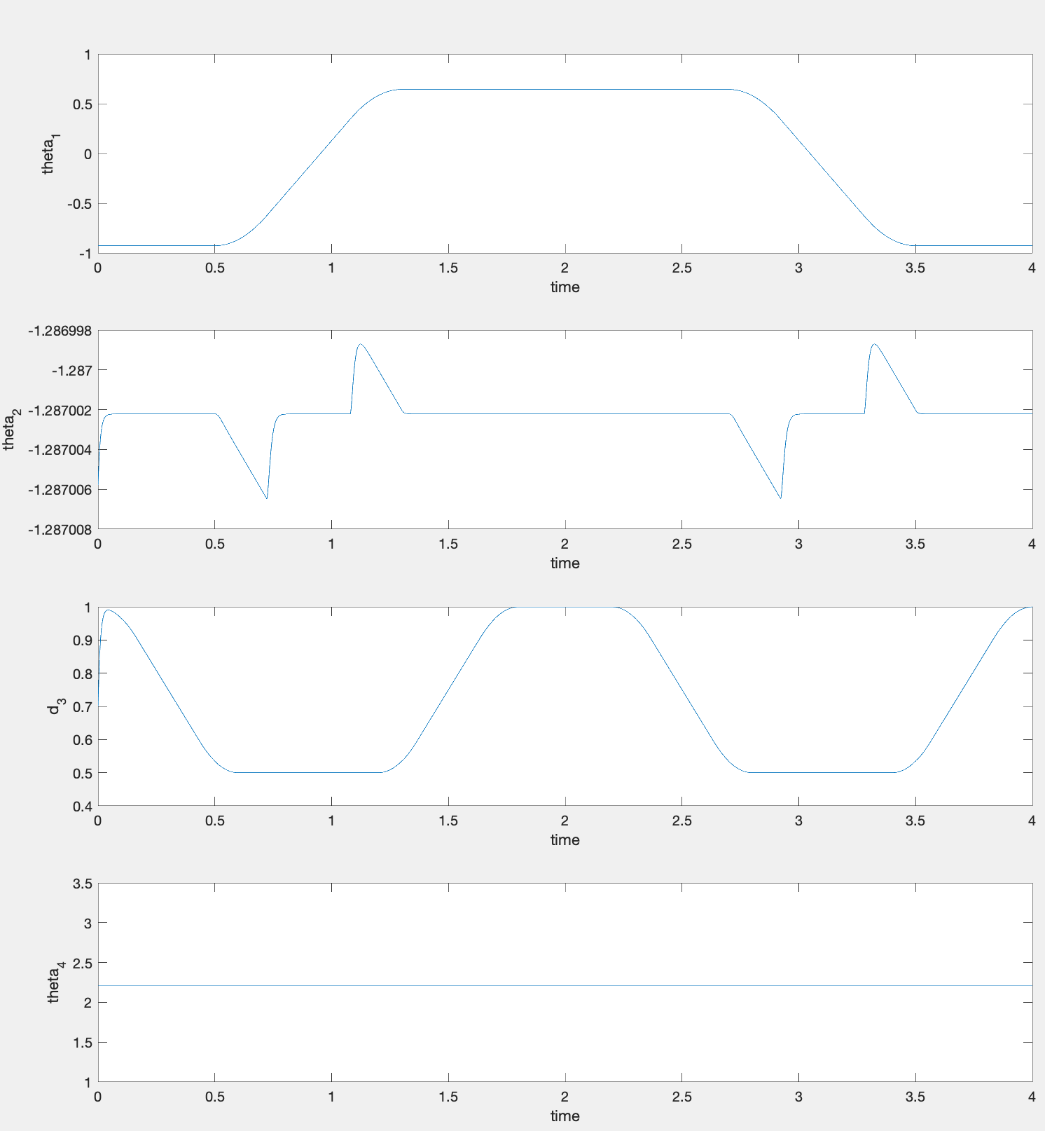

Joint Variables plot in the operational space:

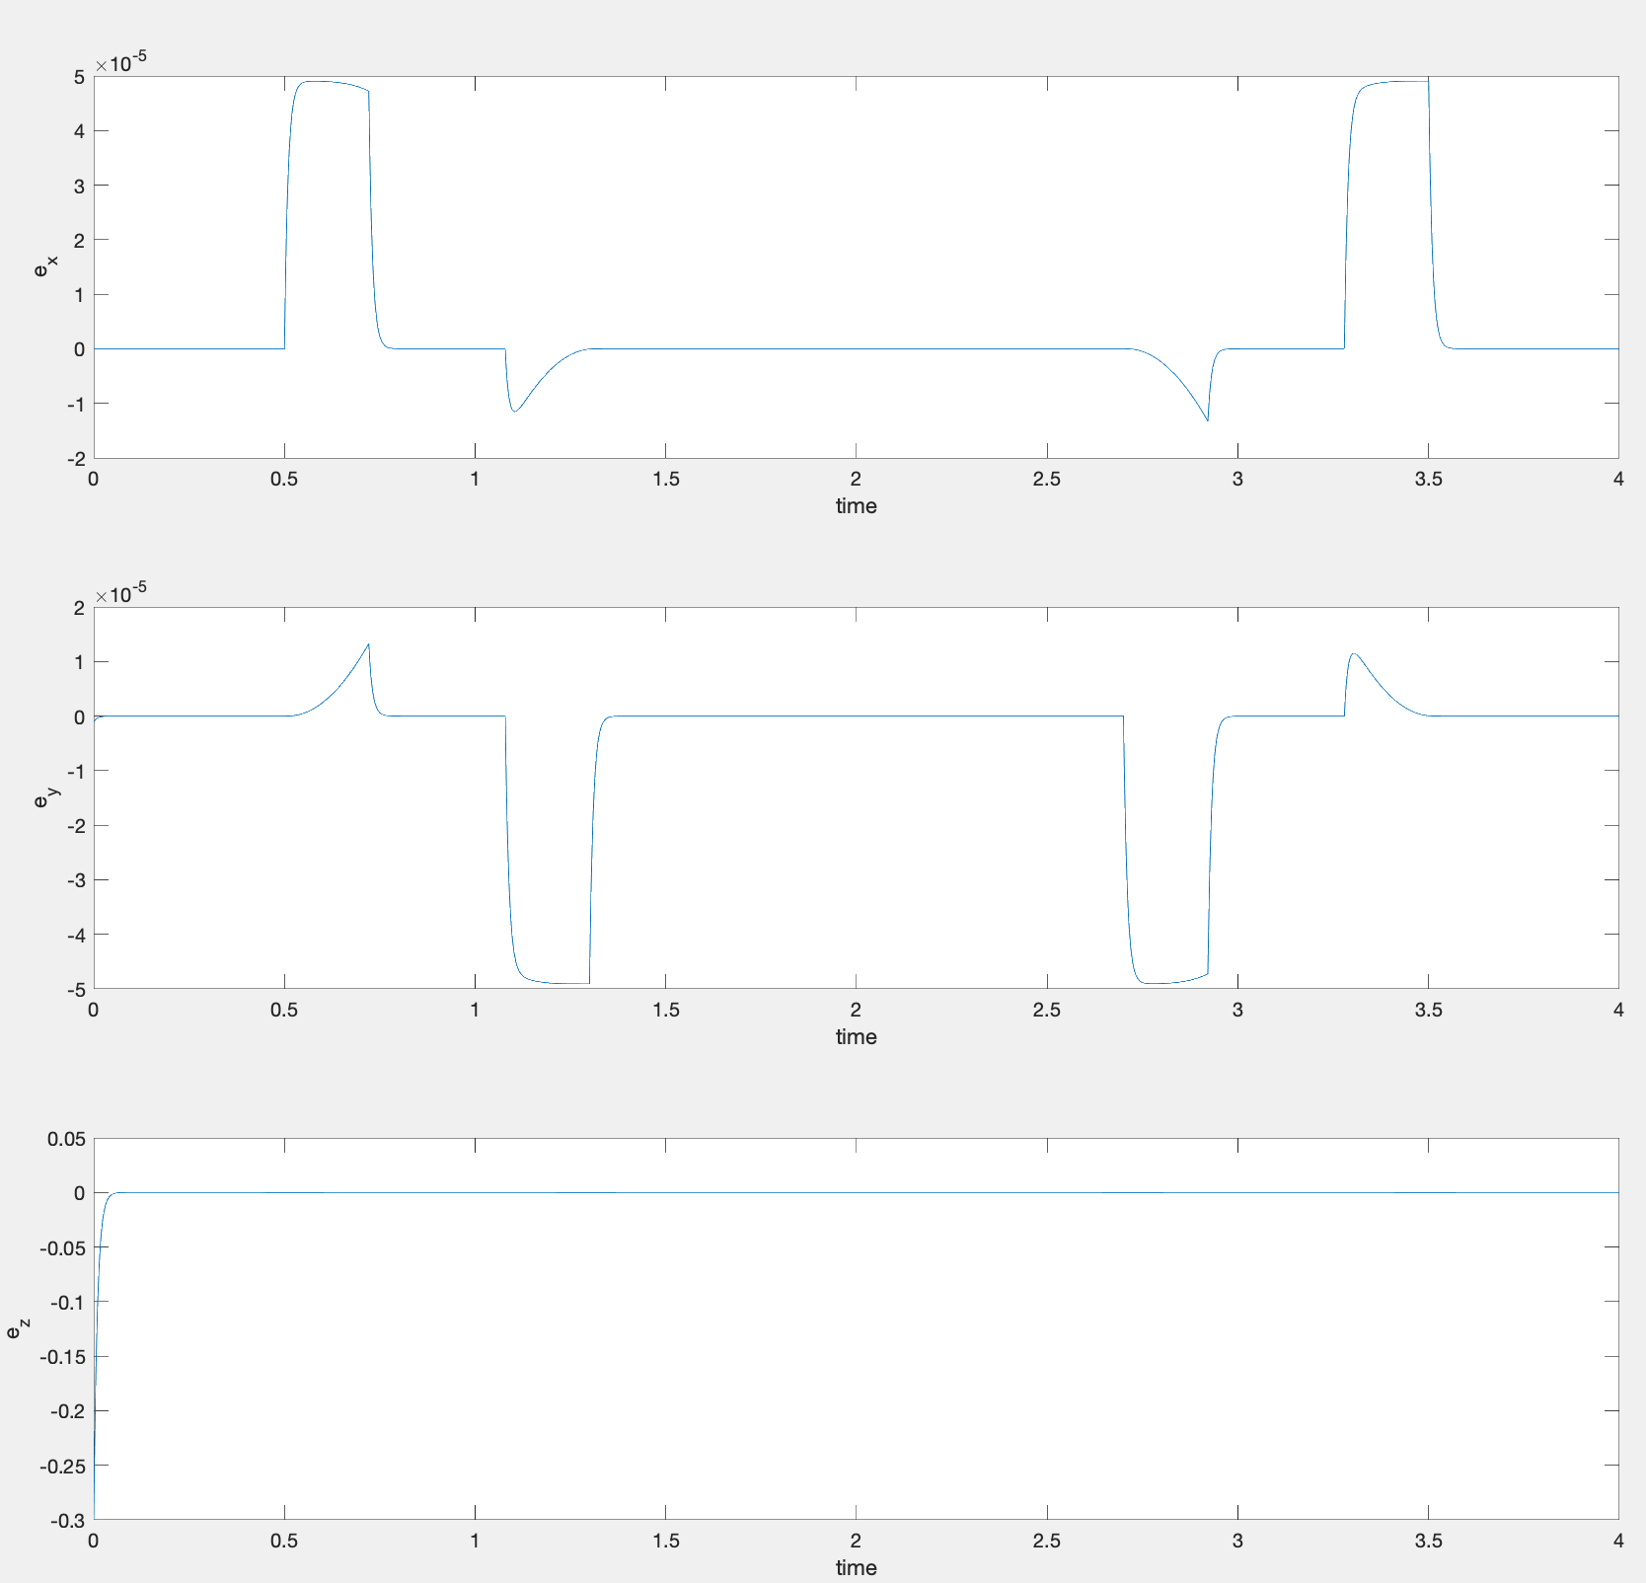

Error Variables plot in the operational space:

**Relaxing the z component**

1. **Explain how you would write the jacobian pseudo-inverse supposing that there is a sphere located at  with radius 0.2 m. Assume you relax the z component in this case.**

133

1. **Plot the joint variables and errors in the operational space. Explain the how the constraints are satisfied from the plots you have obtained.**

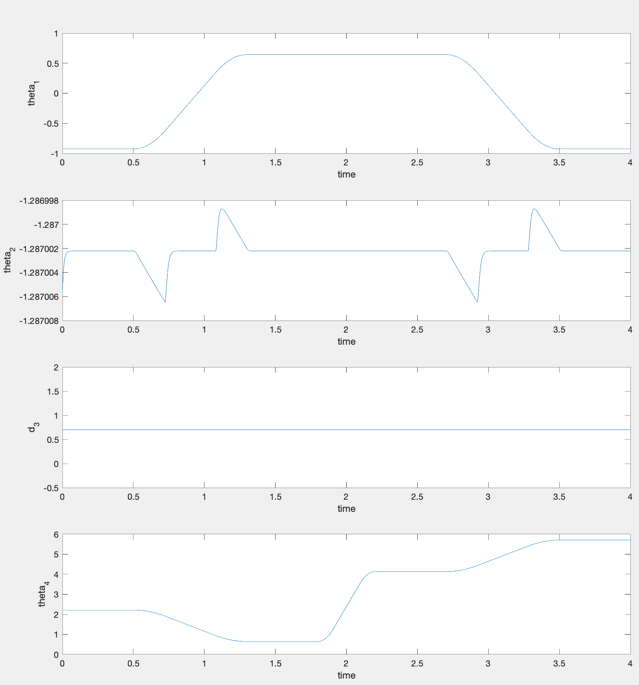

Joint Variables plot in the operational space:

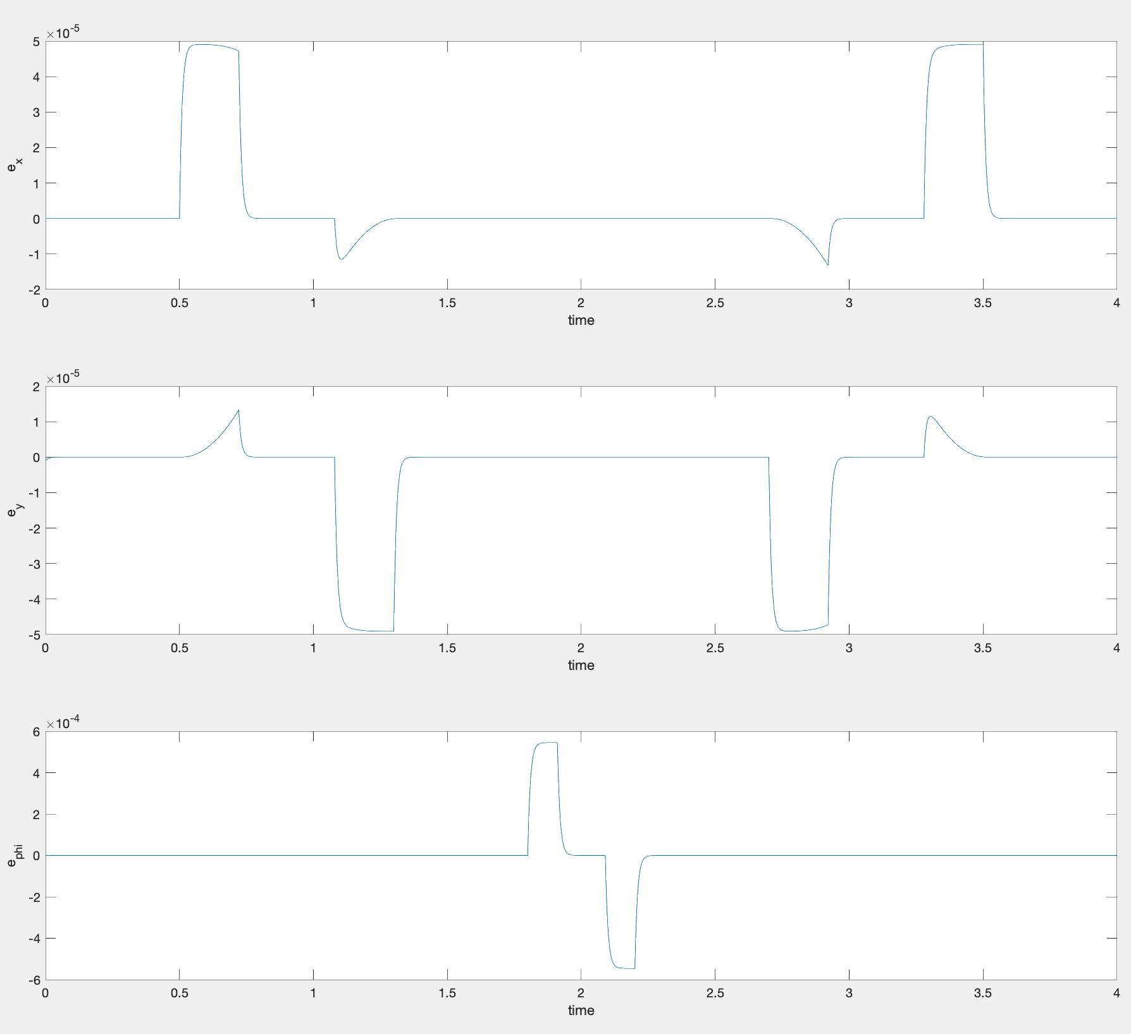

Error Variables plot in the operational space: